PROJECT REPORT FOR
Foundations of Artificial Intelligence

AI GOVERNMENT SCHEME ELIGIBILITY ADVISOR

A PROJECT REPORT

Submitted by
2116240701209 – JATHIN CHOWDARY C H


October, 2026

BONAFIDE CERTIFICATE

Certified that this project report “AI GOVERNMENT SCHEME ELIGIBILITY ADVISOR” is the bonafide work of “JATHIN CHOWDARY C H (240701209)” who carried out the project work under my supervision.

SIGNATURE OF THE FACULTY INCHARGE

Submitted for the Practical Examination held on _________________

SIGNATURE OF THE INTERNAL EXAMINER

TABLE OF CONTENTS

Chapter No | Chapter Title | Page No
1 | Abstract | 4
2 | Introduction | 5
3 | Literature Review | 6
4 | Proposed system | 7
5 | Architecture Diagram | 8
6 | Modular Description  6.1 - User registration & profile assessment  6.2 – Government Scheme data management  6.3 – Rule based eligibility evaluation  6.4- Scheme recommendation and result | 9
7 | Implementation and Result | 14
8 | Conclusion and Future work | 19

9 | References | 21

CHAPTER 1
ABSTRACT
Citizens often face difficulties in identifying government welfare schemes and financial assistance programs that are suitable for their personal, educational, employment, and economic circumstances. The lack of awareness about eligibility requirements, application procedures, and available benefits may prevent eligible individuals from accessing government support. Therefore, an effective system is needed to simplify the discovery of relevant government schemes and help citizens understand their eligibility criteria.
This project proposes an AI Government Scheme Eligibility Advisor, a web-based application designed to help citizens identify government schemes that may match their individual profiles. The system allows users to register, log in, and provide information such as personal details, social category, annual income, educational qualifications, employment status, family details, and special conditions through a structured profile assessment process.
The application uses a rule-based eligibility engine to compare the information provided by users with the eligibility criteria available in the scheme dataset. Based on the evaluation, the system presents potentially relevant schemes, displays matching criteria, and identifies conditions that may not be satisfied. Users can view scheme descriptions, benefits, eligibility requirements, and available official website links to obtain further information and proceed with the application process where applicable.
The proposed system combines web technologies, secure user authentication, structured scheme data management, input validation, and rule-based decision logic to make government scheme discovery more accessible, transparent, and user-friendly. It aims to reduce the effort required to search for relevant welfare programs and improve citizens' awareness of available government assistance. The project contributes to SDG 1 – No Poverty, SDG 10 – Reduced Inequalities, and SDG 16 – Peace, Justice and Strong Institutions by supporting access to public welfare information and promoting inclusive digital services.

CHAPTER 2
INTRODUCTION
Government welfare schemes play an important role in supporting citizens through financial assistance, educational support, healthcare benefits, employment opportunities, and social welfare programs. In India, various Central and State Governments introduce schemes to improve the quality of life of citizens belonging to different economic and social backgrounds. However, many people are unaware of the schemes available to them or find it difficult to understand the eligibility requirements and application procedures.
The lack of accessible and organized information creates several challenges. Citizens may spend considerable time searching multiple government websites to identify suitable schemes. Eligibility conditions related to age, annual income, educational qualifications, employment status, social category, family circumstances, and state of residence can vary from one scheme to another. As a result, individuals may overlook relevant schemes or struggle to determine whether they satisfy the required conditions.
Citizens may also face difficulties in understanding the specific criteria they meet and the requirements they do not satisfy. Information scattered across different portals can make the discovery process confusing, particularly for individuals who are unfamiliar with digital government services. A centralized and user-friendly system can help simplify this process by organizing scheme information and evaluating eligibility conditions systematically.
The proposed AI Government Scheme Eligibility Advisor addresses these challenges by providing a web-based platform that helps citizens discover government schemes that may be relevant to their circumstances. The system allows users to create an account and complete a structured profile containing personal, educational, financial, employment, and family details.
The application uses a rule-based eligibility engine to compare the information provided by users with the eligibility criteria available in the scheme dataset. Based on the evaluation, the system presents potentially relevant schemes, explains matching and unmet criteria, and provides available official links for further information. This approach helps users understand scheme requirements without manually examining every scheme individually.
The proposed system aims to make government scheme discovery more accessible, transparent, and efficient.

CHAPTER 3
LITERATURE REVIEW

Digital government platforms have increasingly focused on improving access to public services, welfare programs, financial assistance, and citizen information. Government portals provide details about various Central and State Government schemes, including their objectives, eligibility requirements, benefits, and application procedures. These platforms play an important role in making welfare information available to citizens through digital channels.
Existing government scheme portals help users search for schemes based on categories, departments, and other available filters. However, citizens may still need to examine multiple schemes individually to determine whether they satisfy the relevant eligibility conditions. Differences in requirements related to age, income, education, employment, social category, family circumstances, and state of residence can make the process time-consuming and difficult to understand.
Rule-based decision-support systems provide a systematic approach to evaluating conditions against predefined rules. Such systems compare user-provided information with specified criteria and generate results based on the conditions satisfied. The proposed AI Government Scheme Eligibility Advisor applies this approach to compare citizen profiles with the eligibility requirements available in its scheme dataset.
Web-based recommendation systems can improve the presentation of information by organizing results according to user needs and preferences. In the proposed application, scheme recommendations are generated using rule-based eligibility evaluation, while the results interface presents matching criteria and unmet requirements to help users understand the assessment.
User-friendly interfaces, structured data management, form validation, and secure authentication are also important components of digital public-service applications. By combining these features, the proposed system aims to simplify scheme discovery and make eligibility information easier to understand. It provides a centralized interface for examining available scheme information without requiring citizens to search through numerous individual scheme descriptions manually.

CHAPTER 4
PROPOSED SYSTEM

The proposed system is an AI Government Scheme Eligibility Advisor, a web-based application designed to help citizens identify government welfare schemes that may be relevant to their personal, educational, financial, and family circumstances.
The system begins with user registration and login through a web interface. After authentication, users complete a structured profile assessment form containing information such as personal details, social category, annual income, educational qualifications, employment status, family details, and other relevant circumstances.
The collected information is validated to ensure that required fields are completed and related values satisfy the defined constraints. The profile information is then used by the eligibility evaluation process to assess the user's suitability for schemes available in the system's scheme dataset.
The system uses a rule-based eligibility engine to compare the citizen's profile against the predefined eligibility criteria of each scheme. The engine evaluates relevant conditions and classifies the results according to the criteria fulfilled, unmet, or requiring further verification.
Based on the evaluation, the application displays a list of potentially relevant government schemes. Each recommendation provides available information about the scheme, including its purpose, benefits, eligibility requirements, and official website links. Users can open the scheme details view to examine the criteria matching their profile and understand which requirements may not be satisfied.
The system also provides a centralized results dashboard with eligibility summaries and filtering options to help users explore the available schemes efficiently. The displayed results are generated from the scheme information and rules currently available in the application rather than from a machine-learning prediction model.
The proposed system aims to simplify government scheme discovery, reduce the effort required to compare eligibility conditions manually, and improve citizens' access to organized welfare information. Although the application provides eligibility guidance based on the available data, final eligibility and approval remain subject to verification by the relevant government authority.

CHAPTER 5
ARCHITECTURE DIAGRAM
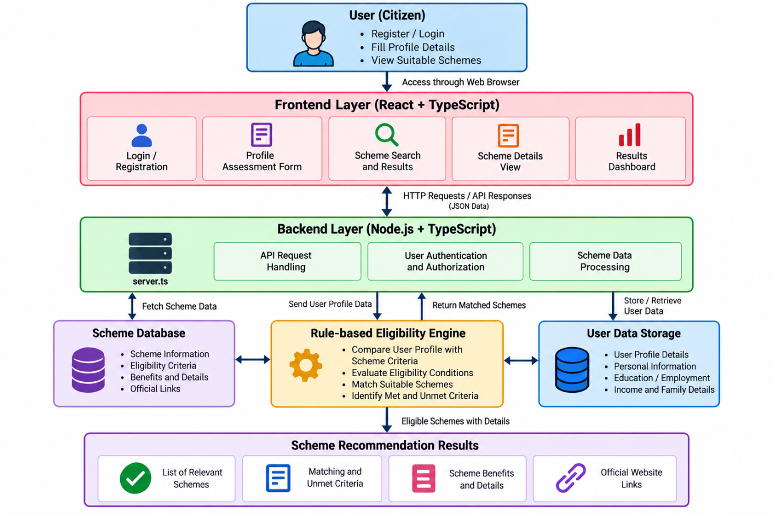

The architecture consists of a frontend layer, backend layer, scheme data and eligibility processing layer, and recommendation results layer. The frontend provides the user interface for registration, login, profile assessment, and scheme exploration. The backend handles server-side requests and related application logic. The rule-based eligibility engine compares the user's profile against the available scheme criteria, and the results layer displays potentially relevant schemes with eligibility explanations and official links.

CHAPTER 6
MODULES DESCRIPTION
The system is divided into four major modules. Each module performs a specific function, and together they form the complete AI Government Scheme Eligibility Advisor system.

Module | Description
Module 1– User Registration and Profile Assessment | Allows citizens to create an account, log in securely, and provide personal, social, financial, educational, employment, and family information through a structured assessment form.
Module 2-Scheme Data Management | Maintains available government scheme information, including descriptions, eligibility criteria, benefits, departments, and official website links.
Module 3 – Rule-Based Eligibility Evaluation | Compares the user's profile with scheme eligibility conditions and identifies fulfilled, unmet, or uncertain criteria.
Module 4 – Scheme Recommendations | Displays potentially relevant schemes, match summaries, criteria breakdowns, scheme details, benefits, and available official links.

6.1 MODULE 1 – USER REGISTRATION & PROFILE ASSESSMENT
This module creates the citizen's profile in the AI Government Scheme Eligibility Advisor system.
The application provides a structured and user-friendly interface that allows citizens to register, log in, and enter the information required for scheme eligibility assessment.
The profile collects details such as personal information, social category, annual income, educational qualifications, employment status, family details, and special conditions. Input validation ensures that required information is provided and related fields satisfy the defined constraints.

Functions
- User registration.
- User authentication.
- Personal information collection.
- Social and category details collection.
- Financial information collection.
- Educational details collection.
- Employment information collection.
- Family details collection.
- Special-condition assessment.
- Input validation and profile management.

6.2 MODULE 2 – GOVERNMENT SCHEME DATA MANAGEMENT
This module manages the government scheme information available in the application.
The scheme dataset contains information such as scheme names, descriptions, benefits, eligibility requirements, responsible departments, and official website links. This information provides the basis for evaluating citizen profiles against scheme-specific conditions.
The module organizes scheme records so that the eligibility engine can access the relevant information during the assessment process. The accuracy of the recommendations depends on the completeness and correctness of the available scheme data.

Functions
- Maintain available government scheme records.
- Store scheme names and descriptions.
- Maintain eligibility criteria.
- Record scheme benefits and assistance details.
- Store responsible ministry or department information.
- Maintain official website links.
- Organize Central and State Government schemes.
- Provide scheme data for eligibility evaluation.
- Support scheme information updates where implemented.

6.3 MODULE 3 – RULE-BASED ELIGIBILITY EVALUATION
This is one of the important decision-processing modules of the system.
The module evaluates the citizen's profile by comparing the provided information with the predefined eligibility conditions of available government schemes.
The system uses a rule-based eligibility engine rather than a machine-learning prediction model. It evaluates relevant conditions, identifies criteria that are fulfilled or unmet, and handles uncertain cases where information is insufficient or requires further verification.
The evaluation results help determine which schemes may be relevant to the citizen. The system provides indicative guidance, while final eligibility and approval remain subject to the relevant government authority's verification.
Functions
- Retrieve citizen profile information.
- Retrieve scheme eligibility criteria.
- Compare profile details with predefined rules.
- Evaluate age and income requirements where applicable.
- Evaluate educational and employment conditions.
- Evaluate social category and family-related conditions where applicable.
- Apply relevant State and Central Government scheme restrictions.
- Identify fulfilled and unmet criteria.
- Handle unknown or insufficient information.
- Generate eligibility evaluation summaries.
- Provide explanations for scheme matching results.
6.4 MODULE 4 – SCHEME RECOMMENDATIONS & RESULTS
This module presents the results of the eligibility evaluation in an organized and user-friendly format.
The results dashboard displays potentially relevant government schemes based on the citizen's profile and the available eligibility rules. Users can explore scheme descriptions, benefits, eligibility requirements, and matching criteria through the scheme details interface.
The system also provides filtering options to help users browse available results and understand why a scheme may match their circumstances. Official website links, when available, help users access further information from the relevant government source.
Functions
- Display potentially relevant government schemes.
- Present eligibility match summaries.
- Show fulfilled and unmet criteria.
- Display scheme descriptions and benefits.
- Provide detailed scheme information.
- Support scheme search and filtering.
- Display available official website links.
- Organize recommendation results for easy navigation.
- Help citizens understand scheme requirements.
- Provide indicative eligibility guidance for further verification.

CHAPTER 7
IMPLEMENTATION AND RESULT
The proposed system is implemented as a web-based application that helps citizens identify government schemes that may match their personal, educational, financial, employment, and family circumstances.
The frontend provides interfaces for user registration, login, profile assessment, and scheme recommendations. The backend server handles server-side requests and application logic, while the scheme dataset and rule-based eligibility engine support the evaluation process.
The application compares user-provided information with available scheme eligibility criteria and displays potentially relevant schemes along with matching conditions, scheme details, and available official website links.

7.1 IMPLEMENTATION SETUP
Frontend
- Web-based user interface.
- React and TypeScript.
- Login and registration pages.
- Citizen profile assessment forms.
- Personal, social, financial, educational, employment, and family information collection.
- Scheme recommendation dashboard.
- Scheme details modal.
- Search and filtering options.

Backend
- Node.js server using TypeScript.
- Server-side request handling through server.ts.
- User-related operations through the relevant service modules.
- Scheme data access and management.
- API request processing, where implemented.
- Integration with the configured authentication provider.
Scheme Data Management
The application uses available scheme records and eligibility information to evaluate citizen profiles.
The scheme data includes:
- Scheme names and descriptions.
- Eligibility criteria.
- Benefits and financial assistance details.
- Responsible ministries and departments.
- Central and State Government scheme classifications.
- Official website links.
- Other scheme information available in the dataset.
Eligibility Processing Layer
The eligibility processing layer uses a rule-based approach to compare citizen profiles with scheme requirements.
Its functions include:
- Reading relevant citizen profile information.
- Evaluating predefined eligibility conditions.
- Comparing profile values against scheme criteria.
- Identifying fulfilled and unmet conditions.
- Handling uncertain or insufficient information.
- Generating eligibility summaries.
- Supporting the scheme recommendation process.
Security Layer
The application incorporates authentication and input validation to support secure access and reliable data handling.
Its functions include:
- User registration and login.
- Email and password validation.
- Authentication error handling.
- Required-field validation.
- Validation of related profile fields.
- Protection of authenticated application routes, where implemented.
- User-specific profile access and persistence, where configured.

PROPOSED AI AND DECISION-MAKING TECHNIQUES
1. Rule-Based Eligibility Evaluation
The system compares citizen information against predefined scheme eligibility criteria. It evaluates applicable conditions and identifies which requirements appear to be fulfilled or unmet.
2. Criteria Matching and Classification
The application organizes evaluation results into understandable eligibility categories. These results help users distinguish potentially relevant schemes from schemes whose requirements may not match their profiles.
3. Scheme Recommendation
The recommendation module presents schemes based on the results generated by the eligibility engine. Users can explore matching criteria, scheme benefits, and other available information.
4. Input Validation
Validation rules check required fields and ensure that related values satisfy defined constraints before the profile assessment is submitted.
5. Explainable Eligibility Results
The system displays the criteria used during evaluation so that users can understand why a scheme may match their profile and which conditions may require attention.
The application uses a rule-based eligibility engine rather than a machine-learning prediction model. Its results depend on the accuracy and completeness of the scheme information and rules available in the application.
7.2 RESULTS
The implemented application provides a centralized interface for citizen profile assessment and government scheme discovery. Users can register, log in, enter their profile information, and view scheme recommendations generated from the available dataset and eligibility rules.
The system displays scheme details, eligibility match summaries, fulfilled and unmet criteria, benefits, and available official website links. The results dashboard allows users to explore the available recommendations and examine the conditions associated with individual schemes.
The application demonstrates the integration of frontend development, backend server functionality, structured scheme data, input validation, and rule-based decision processing in a web-based public-service application.
The accuracy and usefulness of the recommendations depend on the correctness of the citizen's information and the scheme data available in the system. The results provide indicative eligibility guidance and do not represent official government approval.
Observed System Outputs
- User registration and login interface.
- Citizen profile assessment across multiple sections.
- Input validation for required fields and related values.
- Scheme recommendation dashboard.
- Eligibility match summaries.
- Fulfilled and unmet criteria breakdown.
- Detailed scheme information view.
- Available official website links.
EXPECTED SYSTEM OUTPUT
Citizen → Web Application → Profile Assessment → Scheme Dataset → Rule-Based Eligibility Evaluation → Scheme Recommendations
The final system provides a centralized platform that combines citizen profile information + scheme eligibility criteria + transparent matching results + official scheme information to simplify government scheme discovery.

CHAPTER 8
CONCLUSION AND FUTURE WORK

The AI Government Scheme Eligibility Advisor provides a web-based solution for simplifying the discovery of government welfare schemes. The system helps citizens explore schemes that may be relevant to their personal, educational, financial, employment, and family circumstances.
The application collects citizen profile information and compares it with the available government scheme eligibility criteria using a rule-based eligibility engine. Based on this evaluation, the system displays potentially relevant schemes, eligibility match summaries, fulfilled and unmet conditions, scheme benefits, and available official website links.
The system combines web application technologies, user authentication, structured scheme data management, input validation, and rule-based decision-making to provide a centralized and user-friendly platform for government scheme discovery. By presenting eligibility conditions in an understandable format, the application helps citizens identify potentially suitable schemes and understand the requirements that may affect their eligibility.
The main objective is not simply to display government scheme information, but to provide a personalized and explainable eligibility assessment that reduces the effort required to compare scheme requirements manually.
The project supports the broader objectives of SDG 1 – No Poverty, SDG 10 – Reduced Inequalities, and SDG 16 – Peace, Justice and Strong Institutions by improving access to organized public welfare information and supporting inclusive digital services.
FUTURE WORK
- Expand the scheme dataset with additional verified Central and State Government schemes.
- Introduce authorized data sources or official integrations for updating scheme information.
- Add support for more Indian regional languages.
- Improve accessibility for users with limited digital literacy.
- Enhance eligibility explanations and criteria matching.
- Improve the handling of incomplete, uncertain, or conflicting profile information.
- Add notifications about relevant scheme updates, where reliable data sources are available.
- Improve mobile responsiveness and user experience.
- Strengthen authentication, profile privacy, and database security.
- Introduce administrative tools for maintaining and verifying scheme records.
- Conduct further testing using diverse citizen profiles and verified scheme criteria.
- Evaluate recommendation accuracy using documented test cases and actual scheme requirements.

CHAPTER 9
REFERENCES

- Government of India. (2015) Digital India Programme. Available at: https://www.digitalindia.gov.in/
- Government of India. (2022) myScheme: National Platform for Government Schemes. Available at: https://www.myscheme.gov.in/
- Government of India. (n.d.) National Portal of India. Available at: https://www.india.gov.in/
- Node.js. (n.d.) Node.js Documentation. Available at: https://nodejs.org/docs/
- React. (n.d.) React Documentation. Available at: https://react.dev/
- TypeScript. (n.d.) TypeScript Documentation. Available at: https://www.typescriptlang.org/docs/
- United Nations. (2015) The 17 Sustainable Development Goals. Available at: https://sdgs.un.org/goals

